NM PROJECT REPORT

1. INTRODUCTION

1.1 OVERVIEW:

Creating a captivating promo video is an essential marketing tool in today's digital age. These videos serve as dynamic, engaging advertisements for products, services, or events, designed to pique the interest of your target audience. The key to a successful promo video lies in its ability to convey your message effectively within a short time frame, typically ranging from 15 seconds to a few minutes. It should be visually appealing, emotionally resonant, and informative, grabbing the viewer's attention from the very beginning. Careful planning, scripting, and storyboarding are crucial, as is the use of high-quality visuals and sound. A compelling voiceover or music can add another layer of appeal. Finally, a strong call to action at the end can prompt viewers to take the desired next step, whether it's making a purchase, signing up, or sharing the video with others. Crafting a promo video is an art form that combines creativity, storytelling, and marketing strategy to leave a lasting impact on your audience.

1.2 PURPOSE:

The purpose of making a promotional video can vary depending on the goals and objectives of the organization or individual creating it. Here are some common purposes for creating promo videos:

1. Marketing and Advertising: Promo videos are often used to promote products, services, or events. They can be an effective way to grab the audience's attention and communicate the key features and benefits of what is being promoted.
2. Brand Awareness: Promo videos can help build and enhance brand recognition. They convey the brand's identity, values, and personality, creating a lasting impression in the minds of the audience.
3. Education: Promo videos can be used to educate the audience about a product, service, or topic. They can explain complex concepts in a simplified manner and provide valuable information.
4. Fundraising: Non-profit organizations often use promo videos to raise awareness about their causes and encourage donations or support. These videos can tug at the heartstrings of viewers and inspire them to take action.
5. Event Promotion: Whether it's a conference, concert, trade show, or any other event, promo videos can create buzz and excitement around the event, encouraging people to attend.
6. Training and Onboarding: In a corporate or educational setting, promo videos can be used for employee training, onboarding, or to introduce new courses or programs.
7. Recruitment: Promo videos can showcase a company's culture, work environment, and job opportunities, making it an effective tool for attracting potential employees.
8. Entertainment: In the entertainment industry, promo videos are created to generate interest in upcoming movies, music releases, or other forms of entertainment.
9. Product Launch: When a new product is about to be released, a promo video can generate excitement and anticipation among potential customers.

10. Customer Testimonials: Promo videos featuring satisfied customers or clients can build trust and credibility, as they provide social proof of the product or service's quality.

Ultimately, the purpose of a promo video is to communicate a message, evoke emotions, and persuade the viewer to take a specific action, whether it's making a purchase, supporting a cause, attending an event, or simply learning more about a topic. The specific goals and objectives of the video will determine its content, style, and distribution strategy.

2. PROBLEM DEFINITION AND DESIGN THINIKING:

2.1 Empathy Map:

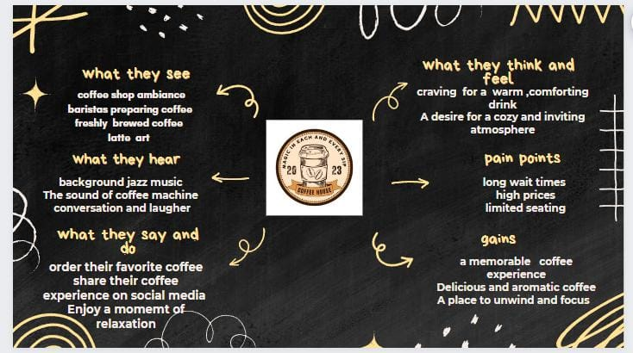

2.2 Ideation and Brainstorming:

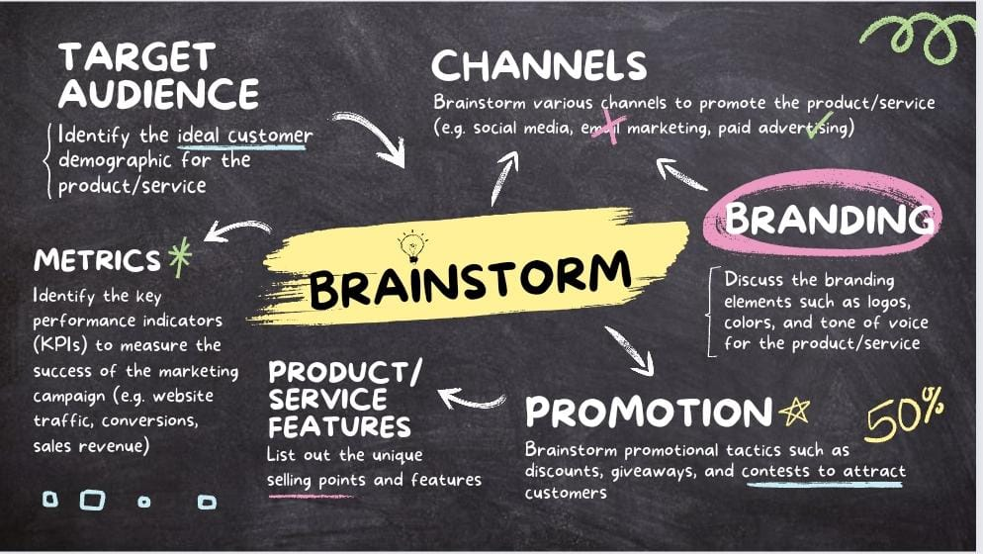

3. RESULT:

The result of making a promo video is a powerful tool that not only showcases your product, service, or message but also leaves a lasting impression on viewers and we have made the promo video of our brand COFFEE HOUSE which turned be good.

Advantages :

Attention – grabbing : Videos are more likely to grab viewers attention than text or images especially on social media.

Engaging : Videos can be used to tell stories, demonstrate products, and connect with viewers on an emotional level.

Informative : Videos can complex information in a clear and concise way.

Versatile : Videos can be used in variety of marketing channels, including websites, social media, email and paid advertising.

Effective : Studies have shown that videos are effective at increasing brand awareness generating leads, and driving sales.

Disadvantages :

Time – consuming and expensive to produce : High-quality promotional videos can be time-consuming and expensive to produce, especially if you need to hire professional actors, videographers and others.

Difficult to measure ROI : It can be difficult to measure the ROI of promotional videos, as there are many factors that can contribute to a successful video campaign.

May not be suitable for all audiences : Not all audiences are engaged by video content. For example, some may prefer to read text or not to use them in your marketing strategy.

Conclusion :

Overall, promotional videos can be very effective marketing tool, but it is important to weigh the pros and cons before deciding whether or not to use them in your marketing strategy. We also learned on how effective a promotional video can be created by defining the goals, knowing the audience, using high-quality content and the way we promote the video.